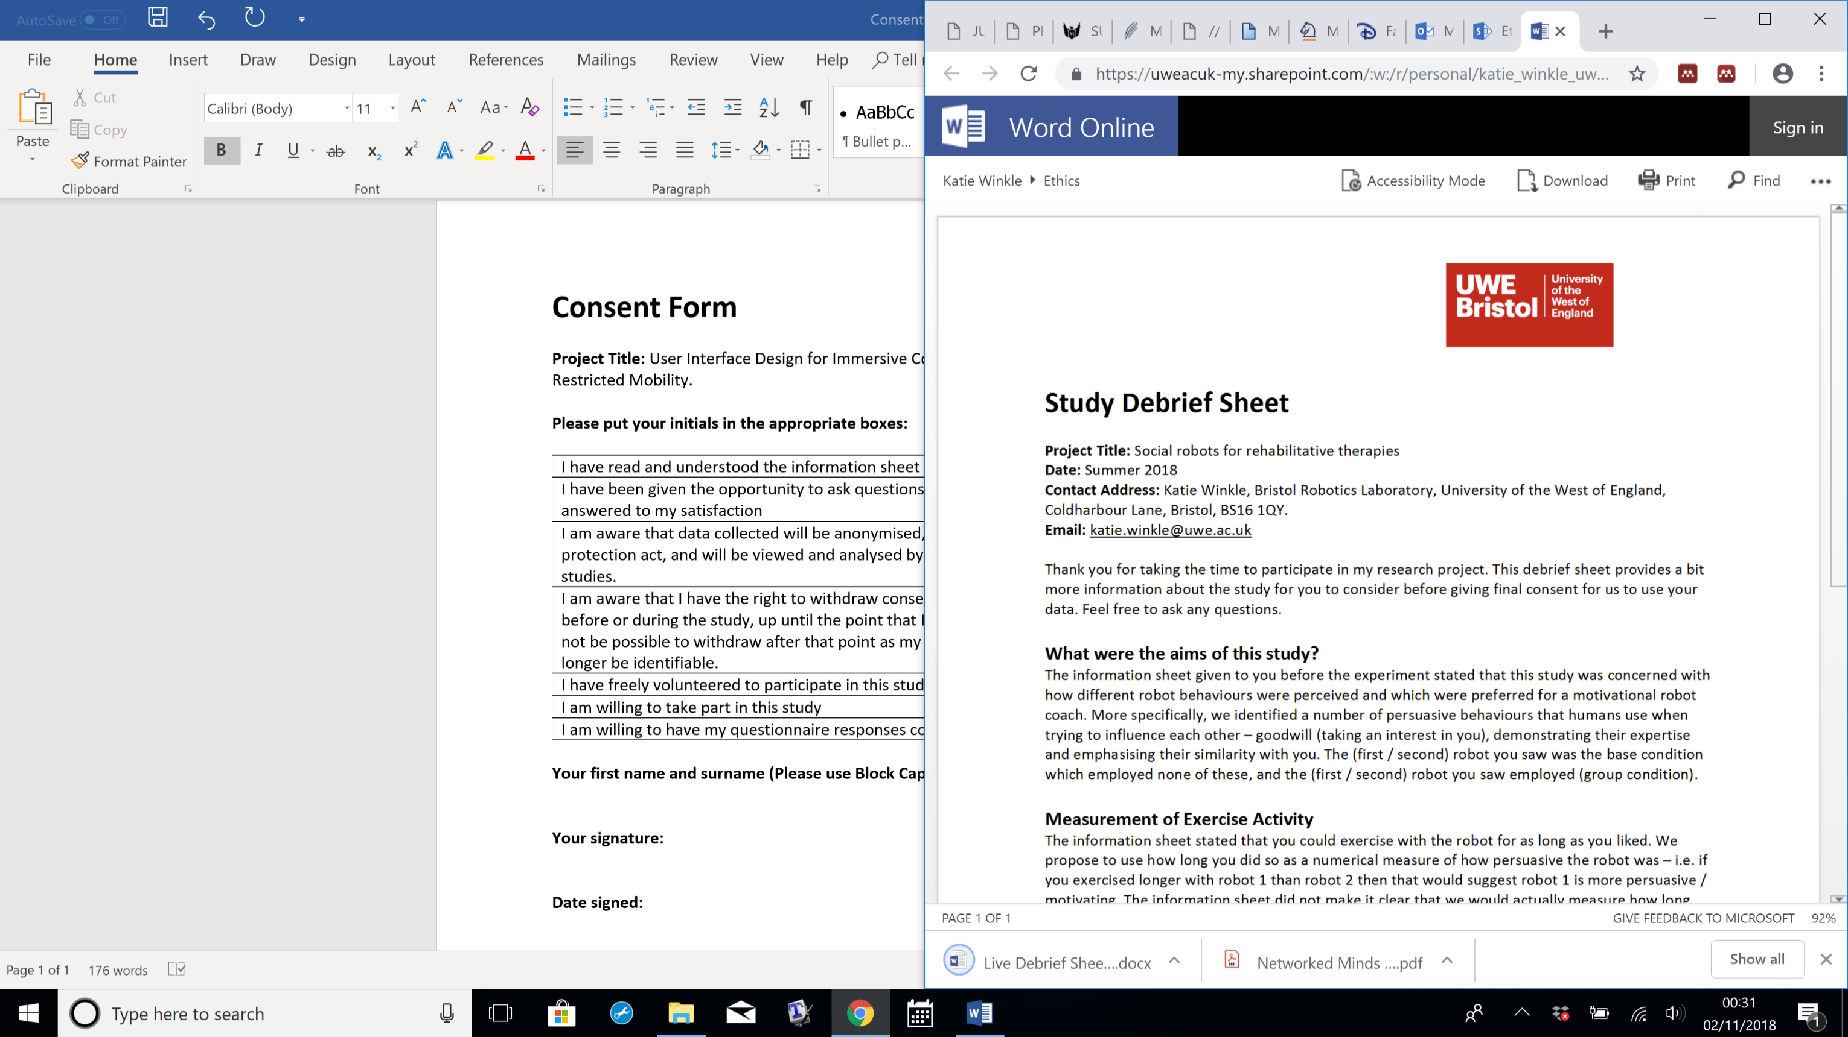

Faculty of Environment & Technology

Faculty Research Ethics Committee (FREC)

**Ethical Review Checklist for Undergraduate and Postgraduate Modules**

Staff and PG research students must not use this form, but should instead, if appropriate, submit a full application for ethical approval to the Faculty Research Ethics Committee (FREC).

*Please provide project details and complete the checklist below.*

**Project Details:**

|  |  |
| --- | --- |
| **Module name** | **MSc Robotics** |
| **Module code** |  |
| **Module leader** | Paul O’Dowd |
| **Project Supervisor** | Manuel Giuliani |
| **Proposed project title** | **Human Robot Interaction Coursework:** User’s respond to robots with different conversational styles. |

**Applicant Details:**

|  |  |
| --- | --- |
| **Name of Student** | Runze Yuan |
| **Student Number** | 22071714 |
| **Student’s email address** | Runze2.Yuan@live.uwe.ac.uk |

| **CHECKLIST QUESTIONS** | | **Yes/No** | **Explanation** |
| --- | --- | --- | --- |
|  | Does the proposed project involve **human tissue,** **human participants, animals, environmental damage, or the NHS.** | No | *If the answer to this is ‘No’ then no further checks in the list need to be considered.* |
|  | Will participants be clearly asked to give consent to take part in the research and informed about how data collected in the research will be used? | Yes | We show the participants how would the process be like, and how would we collect the data. The participants sign for agreement. |
|  | If they choose, can a participant withdraw at any time (prior to a point of “no return” in the use of their data)? Are they told this? | Yes | Our experiment is similar to some kind of interview, and there is no “no return” point for our research, any participant could withdraw at any time. |
|  | Are measures in place to provide confidentiality for participants and ensure secure management and disposal of data collected from them? | Yes | We would use numbers instead of names while collecting the data. Participants’ identity information is not needed for our research. |
|  | Does the study involve people who are particularly vulnerable or unable to give informed consent (eg, children or people with learning difficulties)? | No |  |
|  | Could your research cause stress, physical or psychological harm to humans or animals, or environmental damage? | No |  |
|  | Could any aspects of the research lead to unethical behaviour by participants or researchers (eg, invasion of privacy, deceit, coercion, fraud, abuse)? | No |  |
|  | Does the research involve the NHS or collection or storage of human tissue (includes anything containing human cells, such as saliva and urine)? | No |  |

Your explanations should indicate briefly for Qs 2-4 how these requirements will be met, and for Qs 5-8 what the pertinent concerns are.

* **Minimal Risk:** If **Q 1 is answered ‘No’**, then no ethics approval is needed.
* **Low Risk:** If **Qs 2-4 are answered ‘Yes’ and** **Qs 5-8 are answered ‘No’**, then no approval is needed from the *Faculty Research Ethics Committee* (FREC). However, your supervisor must approve (a) your information and consent forms (Qs 2 & 3) and (b) your measures for participant confidentiality and secure data management (Q4).
* **High Risk:** If **any of Qs 5-8 are answered ‘Yes’**, then you must submit an application for full ethics approval *before* the project can start.This can take up to 6 weeks. Consult your supervisor about how to apply for full ethics approval.

**Risk Assessment:** Separate guidance on risk assessment can be found on UWE’s Health and Safety forms webpage at <https://go.uwe.ac.uk/RiskAssessment>. If needed, you must complete a Risk Assessment form. This must also be attached to your application for full ethics approval if your project is **High Risk**.

|  |
| --- |
| **Your supervisor must check your responses above before you submit this form.** |
| **Submit this completed form via the *Assignments* area in Blackboard (or elsewhere if so directed by the module leader or your supervisor)***.* |
| After you have uploaded this form, your supervisor will confirm it has been correctly completed by “marking” it as *Passed*/100% via the *My Grades* link on the Blackboard*.* |

Further research ethics guidance is available at <http://www1.uwe.ac.uk/research/researchethics>